1.INTRODUCTION
Road potholes are one of the major causes of road accidents, traffic congestion, vehicle damage, and transportation inefficiency in many countries, especially in India. Poor road maintenance directly affects public safety and economic development. Traditional road inspection methods depend on manual monitoring by road maintenance authorities, which is expensive, time-consuming, and inefficient. With the rapid development of Artificial Intelligence, Machine Learning, and Computer Vision technologies, it has become possible to automate road damage detection systems. This project proposes an AI-powered pothole detection system using smartphone cameras. The system captures road images or videos and automatically detects potholes using Deep Learning algorithms. The detected potholes are classified into severity levels such as Small, Medium, and Dangerous. GPS coordinates are attached to the pothole locations and visualized on digital maps. This system helps road authorities prioritize repairs and improve transportation safety. The proposed solution provides a low-cost, scalable, and real-time pothole monitoring system suitable for smart city infrastructure and public road maintenance applications.

2.PROBLEM STATEMENT
Road potholes are increasing due to poor maintenance, heavy traffic, and environmental conditions. Manual road inspection systems require a large workforce and high operational cost. Monitoring every road segment manually is practically impossible for road authorities. Existing pothole detection systems use expensive sensors, drones, or dedicated vehicles that are difficult to deploy widely. Small municipalities and local governing bodies cannot afford these advanced systems. The absence of a low cost, automated, and real-time pothole detection system creates delays in road repair and increases accident risks. There is a need for a smart and economical solution that can detect potholes using commonly available devices such as smartphones.

3.OBJECTIVES
- Detect potholes automatically using smartphone camera images and videos.
- Classify potholes based on severity levels such as Small, Medium, and Dangerous.
- Reduce manual road inspection work and operational costs.
- Store pothole locations using GPS mapping systems.
- Improve transportation safety and road maintenance efficiency.
- Develop a low-cost smart road monitoring system.
- Support smart city infrastructure and intelligent transportation systems.
- Provide real-time pothole monitoring and visualization.

4.EXISTING SYSTEM
Existing pothole detection systems mainly depend on manual road surveys and public complaints. Road authorities inspect roads physically to identify damaged areas and potholes. This process consumes significant time, manpower, and resources. Some advanced pothole detection systems use vibration sensors, accelerometers, drones, LiDAR sensors, or specialized road inspection vehicles. Although these systems provide accurate results, they are expensive and difficult to implement on a large scale.
Limitations of Existing Systems:
- High implementation and maintenance cost.
- Large manpower requirement.
- Slow road inspection process.
- Lack of real-time monitoring.
- Difficult deployment in rural and remote areas.
- Limited accessibility for local municipalities.
- Dependency on costly hardware and sensors.

5.PROPOSED SYSTEM
The proposed system uses Artificial Intelligence and Computer Vision technologies to automatically detect potholes from road images and videos captured using smartphone cameras. The system workflow includes:
- Capturing road images or videos through a smartphone camera.
- Preprocessing the captured images for better detection accuracy.
- Detecting potholes using the YOLOv8 object detection model.
- Drawing bounding boxes around detected potholes.
- Classifying potholes into Small, Medium, and Dangerous categories based on area and dimensions.
- Storing pothole GPS coordinates in the database.
- Displaying pothole locations on Google Maps for maintenance planning. The proposed system is cost-effective, portable, scalable, and easy to use. It provides a practical solution for smart transportation and road safety management.

6.TECHNOLOGIES USED

Component | Technology | Purpose
Programming Language | Python | Backend and AI processing
Computer Vision | OpenCV | Image processing
Deep Learning | YOLOv8 | Pothole object detection
Backend Framework | Flask | Web application backend
Database | Firebase | Pothole data storage
Maps | Google Maps API | GPS mapping
Numerical Library | NumPy | Array and matrix operations

7.METHODOLOGY & SYSTEM ARCHITECTURE
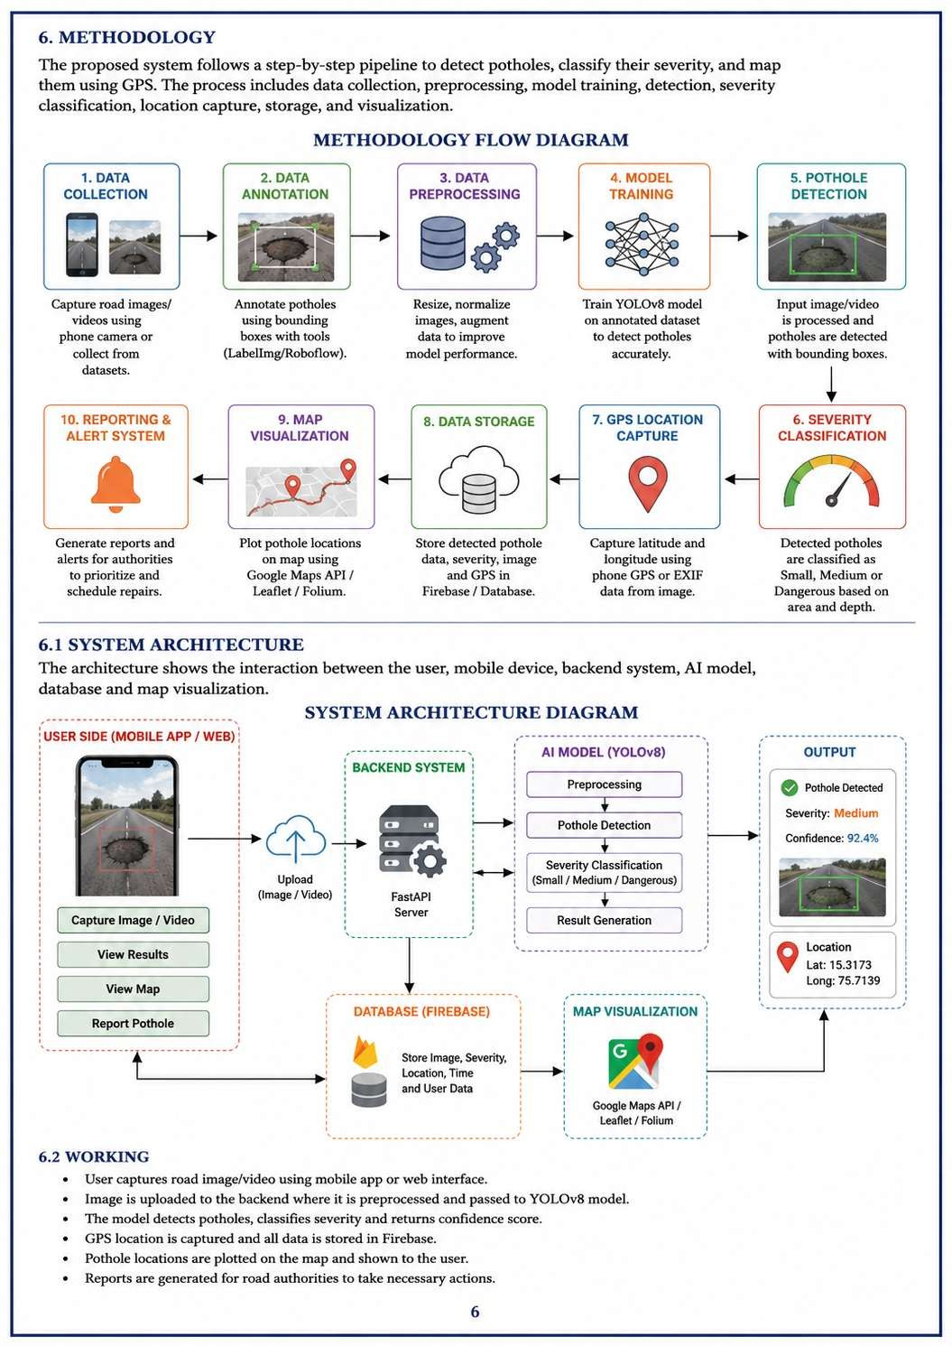

8.DATASET DETAILS
The pothole detection model is trained using datasets collected from Kaggle, Rob flow Universe, and custom smartphone images. Dataset Features:
• Road images containing potholes.
- Normal road surface images.
- Different weather conditions.
- Day-time and night-time road images.
- Multiple pothole shapes and sizes.
- Different road textures and environments. The dataset is annotated using bounding boxes to improve pothole localization accuracy during model training.

9.EXPECTED OUTCOME
- Accurate pothole detection from road images and videos.
- Severity classification into Small, Medium, and Dangerous categories.
- GPS-based pothole mapping system.
- Faster road inspection and maintenance planning.
- Reduced manual road inspection cost.
- Improved transportation safety.
- Real-time pothole monitoring dashboard.
- Smart city compatible infrastructure support.

10.APPLICATIONS & ADVANTAGES
Applications:
- Smart city infrastructure.
- Municipal road maintenance systems.
- Highway monitoring systems.
- Transportation management systems.
- Public safety monitoring.
- Crowd-sourced pothole reporting systems.
Advantages:
- Low-cost implementation using smartphones.
- Real-time pothole detection.
- Reduces manual inspection effort.
- Faster road maintenance response.
- Portable and scalable solution.
- Improves road safety.
- Easy integration with existing transportation systems.

11.FUTURE ENHANCEMENTS
- Development of Android and iOS mobile applications.
- Real-time voice alerts for drivers.
- Drone-based pothole monitoring systems.
- Automatic complaint generation to municipalities.
- Cloud-based pothole monitoring dashboard.
- Night-time pothole enhancement using advanced image processing.
- Integration with traffic analysis systems.
- AI-based road quality scoring system.

12.CONCLUSION
The Road Pothole Severity Detector using Phone Camera provides a smart and economical solution for automatic road damage detection and monitoring. The project combines Artificial Intelligence, Deep Learning, Computer Vision, and GPS technologies to create an intelligent transportation support system. The proposed system reduces manual inspection cost, improves road safety, and helps authorities prioritize road repairs effectively. This project demonstrates how modern AI technologies can solve real world transportation and civic infrastructure problems efficiently.

13.REFERENCES
[1] YOLOv8 Official Documentation.
[2] OpenCV Official Documentation.
[3] Python Official Documentation.
[4] Google Maps API Documentation.
[5] Research papers on pothole detection using AI and Computer Vision.
[6] Rob flow Universe Datasets.
[7] Kaggle Pothole Detection Datasets.
[8] Smart Transportation System Research Papers.

